SEMINAR
“New developments for the most challenging cases of GI cancers”
In conjunction with the visit by prof. Gregory Gores and prof. Nicholas LaRusso from the Mayo Clinic, Rochester, USA, this seminar will take place:
Thursday October 20th, 1330 – 1445
D1.2082 “Medical dept. auditorium” (second floor, between the Research Institute of Internal Medicine and Radiology)
1330 – 1335 Introduction (prof. Kirsten Muri Boberg, Norwegian PSC Research Center, OUS Rikshospitalet/Institute for Clinical Medicine, UiO)
1335 – 1355 Genomic Tumor Heterogeneity and Drug Screening – New Treatment Strategies for Metastatic Colorectal Cancer (prof. Ragnhild A. Lothe, Institute for Cancer Research, OUS Radiumhospitalet/Institute for Clinical Medicine, UiO)
1355 – 1415 Cholangiocarcinoma (prof. Gregory J. Gores, Mayo Clinic, Rochester, MN, USA)
1415 – 1435 Liver Transplantation for Hepatocellular Carcinoma – Experience from Oslo with Extended Criteria (prof. Pål-Dag Line, Dept. of Transplantation Medicine, OUS Rikshospitalet/Institute for Clinical Medicine, UiO)

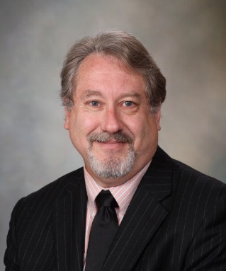 | 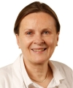 | 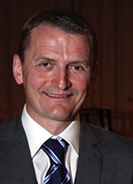
The laboratory-based research program of Gregory J. Gores, M.D., is focused on mechanisms of liver cell death, especially apoptosis. He employs disease-relevant models to unravel the fundamental cellular processes contributing to liver injury during cholestasis and fatty liver diseases. In addition, Dr. Gores' lab is also interested in the mechanisms by which cancer cells escape from cell death in order to undergo malignant transformation and metastases. | Dr. Lothe’s research team studies the genetics and epigenetics of human solid tumours, with special emphasis on colorectal cancer, testicular cancer, and nerve cancer. To gain knowledge of the complex dynamics of cancer development the group combine large-scale and detailed biology research using in vitro models and clinical samples. Their goal is to bring results from molecular biology into clinical utility. | Professor Pål-Dag Line is head of the Department of Organ Transplantation and professor at the University of Oslo. He is a senior vascular and abdominal transplant surgeon. His research is focused around basic and clinical experimental approaches to the treatment of malignant tumors of the liver.

