Conventional radiography and Computer tomography

Conventional radiography (CR)
Standard radiographical protocols are applied to evaluate the development of radiolucencies or positioning of implants.

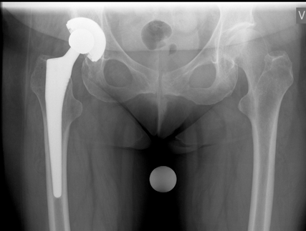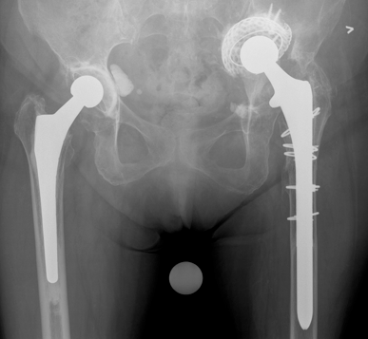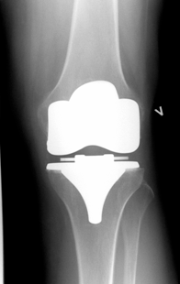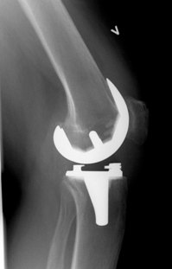

Hip Knee Ankle radiographs (HKA)
This allows validation of the mechanical axis of the lower extremity before and after knee procedures.

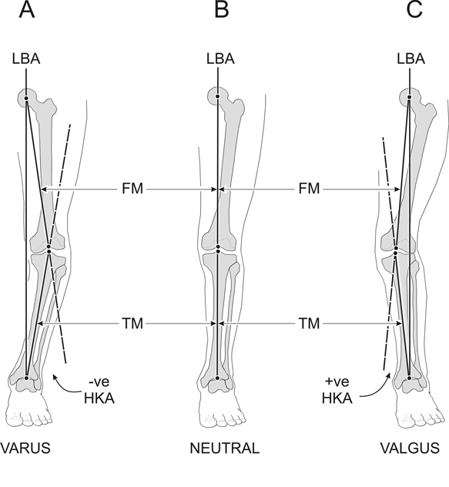

Computer tomography (CT)
New software has made it possible to eliminate metal artefacts caused by implants. We have therefore started to evaluate implant position with CT. This allows exact determination of axis of the extremities.
We have implimented the Perth protocol as baseline for further evaluation of implant position in the knee.

